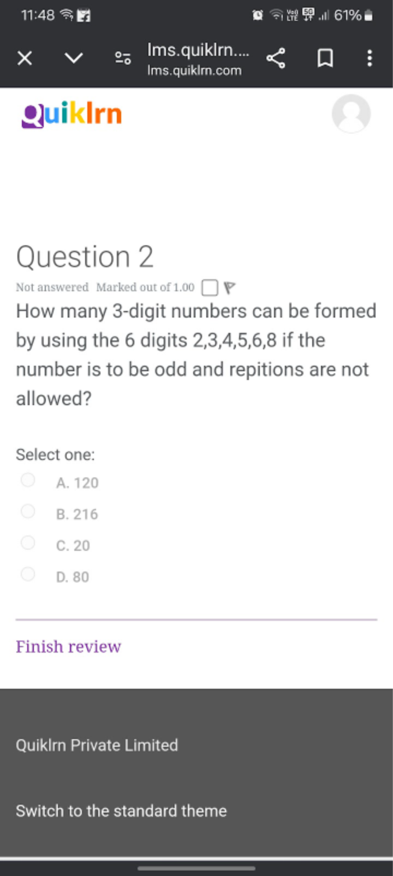

DEPARTMENT OF

**INDUSTRIAL ENGINEERING AND MANAGEMENT**

| Date | 07th July 2023 | Maximum Marks | 25 |
| --- | --- | --- | --- |
| Course Code | 21HSU48 | Duration | 60 Mins |
| Sem | IV | CIE – I | |
| **Universal Human Values** | | | |

| QNo. | **Questions** | M | BT | CO |
| --- | --- | --- | --- | --- |
| 1. | Distinguish between ‘human consciousness’ and ‘animal consciousness’. How “shiksha and sanskar” are helpful in raising man to “human consciousness” level. Explain with the help of a diagram. | 10M | L3 | CO2 |
| 2. | Explain the activities of realization and understanding. How do they lead to harmony in the activities of ‘I’? Illustrate with an example . | 8M | L3 | CO1 |
| 3. | Human beings are the Co-existence of Self and Body. Explain. | 4M | L2 | CO1 |
| 4. | What is the meaning of prosperity? How can you say that you are  prosperous? | 3M | L1 | CO4 |

BT-Blooms Taxonomy, CO-Course Outcomes, M-Marks

| Marks Distribution | Particulars | | CO1 | CO2 | CO3 | CO4 | L1 | L2 | L3 | L4 | L5 | L6 |
| --- | --- | --- | --- | --- | --- | --- | --- | --- | --- | --- | --- | --- |
| Test | Max Marks | 12 | 10 | - | 3 | 3 | 4 | 18 | - | - | - |